**ALVA’S Institute of Engineering & Technology**

**Department of Computer Science & Engineering**

**Online activities report**

**Date: 26/05/2020**

**Faculty Name : Dr.S.Mohideen Badhusha, Prof/CSE**

**Department : CSE**

|  |  |  |
| --- | --- | --- |
| **Sl.#** | **Details of the Activity** | **Progress** |
|  | **Online Test** | |  |  |  |  |  | | --- | --- | --- | --- | --- | | **Semester** | **Subjects** | **Student Strength** | **No. of Students Registered** | **Pass %** | |  |  |  |  |  | |
| **rs** | | |
|  | **Certification Course** | **Name of The Courses : Computer Networking wired and wireless protocols(4 modules- 3 hours)**  **Certificate provider: Alison Course**  **Duration of the course: 3 hours** |
|  | | |
|  | **Coding Challenges** | **Problem statement:** [**Python Program**](https://github.com/orgs/alvas-education-foundation/teams/cse/discussions/66) **using coding Challenge is Given through Techgig with case studies**  **Language used for solving: Python**  **Whether posted in Github: yes**  **How many students attempted : program – 4** |
|  | | |
|  | **Student Monitoring System** | **How many Students assigned: 18**  **How many students uploaded the report in slack : 1**  **How many students are actively involved in online activities: 4 (taking part in various coding challenges)** |

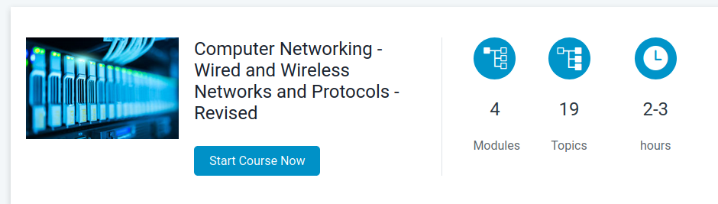

Online Coding Assignment through Techgig link

https://www.techgig.com/challenge/Pythoncodingsample